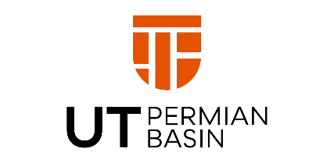

ADDENDUM NUMBER:
November 1, 2021

For

IFB 742-22-194-1
BSC Cabinets Certification

University of Texas Permian Basin
4901 E. University Blvd.
Odessa, TX 79762

The following revisions, additions and clarifications shall be incorporated in the Request for Proposal referenced above. All other provisions of the Request for Proposal shall remain unchanged.

Question and Answers

- At this point, is there an incumbent that has a current contract or is this something new?

This is a new contract.

- Can you share what manufacturer or model of Biosafety Cabinets that are needing to be serviced? Example: Thermo Fisher, Labconco, etc.?
This will help partner as we have access to a lot of options but I’ll need to know more about these units before I can state whether I can bid or not.

Attached are the documents for the BSC we have on campus.

The following revisions, additions and clarifications shall be incorporated in the Request for Competitive Sealed Proposal referenced above. All other provisions of the Request for Proposal shall remain unchanged. BIDDERS MUST ACKNOWLEDGE RECEIPT OF ADDENDUM(S)

-signature ____________________________________________________________________

Pam Jenkins, Procurement Specialist UTPB

End of Addendum

